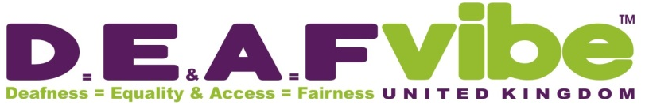
Friend of Scheme

Category: | Terms of Membership:
DEAFvibe Friend : Adult  (over 18 years old) | - This group of volunteers or supporters have no voting rights;  - Are invited to all open events;  - Invited to AGM and other special meetings; can join in the discussions and seek information about DEAFvibe.
DEAFvibe Friend : Junior  (under 18 years old) | - Must be accompanied by an adult, family or legal guardian, who have agreed to be responsible for them;  - Have no voting rights and cannot participate the AGM or other special meetings;  - Subject to the Child Protection Act at all times.
Executive Trustee | - Must be appointed by the Board of Trustees as a fellow Trustee;  - Has full voting powers at AGM and other special meetings;  - Must demonstrate proof of expertise, experience and commitment to the satisfaction of the Board.
Corporate Supporter  (a company, business or other organisation) | - Show they support DEAFvibe Charity by act or deed;  - No voting rights;  - May send representative(s) to open meetings;  - Show a willingness to join in and support our activities and events.

Notes:

Only register once to support DEAFvibe, there is no need to re-register every year and there are no membership fees to become a Friend.

DEAFvibe will always welcome your support both in person and any donations received help us provide more community support to those people who experience hearing loss or Deafness, as well as offer support to their families and friends.

Organisations, Clubs, Charities, Businesses and other groups who join the Friends of DEAFvibe Scheme may be eligible for a free short taster session in British Sign Language or Deaf Awareness (conditions apply). Please email awarenesscourses@deafvibe.co.uk to enquire about this.

Data Protection Act
Each member will be required to complete and sign the “To become a Friend of DEAFvibe” form (attached) to confirm that they are happy for DEAFvibe to store their personal details which will not be passed on to others.


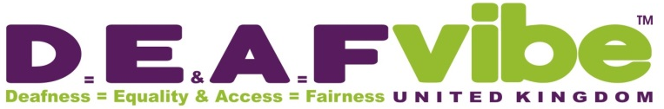
To become a Friend of

I ______________________________________________________________________ (PRINT name) apply to
become a Friend of DEAFvibe and my details are as follow:

Address: __________________________________________________________________________________________

____________________________________________________ Postcode: _______________________

Email: __________________________________________________________________________________________

Contact Number (Home or Mobile: ___________________________________________________________

DEAFvibe Friend: Junior

I ____________________________________________________________ am the parent / guardian (delete)
of the above DEAFvibe Friend: Junior and agree to be responsible for them at any DEAFvibe activities we attend.

Age of Junior if under 18: _____________

DEAFvibe Friend Category: ________________________________________________________________
(Adult / Junior / Executive Trustee / Corporate Supporter

I confirm that the Charity DEAFvibe must not use my personal information other than to provide me with information about activities, events, updates etc.

I agree to my name being added to the DEAFvibe Support Roll of Honour which is used to show proof to our sponsors how many dedicated supporters and friends we have.

I request that DEAFvibe ask for my permission to use my details for any other use.

I acknowledge that these details will be held in a secure unit or computer as part of the Data Protection Act.

Signature: ____________________________________________________

Date: ____________________________________________________

